

**Practice Exercise 1-14**

**9%**

**INSTRUCTOR:** “Ahmad Alhamed”

**CLASS:** CSD 1103

• For this exercise you will need to post the resulting webpage to Moodle, under the Assignment Section.

**Student Name**: …………………………………………

**Student Number**: ………………………………….….

**Student Section**: ………………………………………

**Date:** …….…Oct 8th, 2022……….……..

**Write and submit the webpages (.html) that is shown below:**

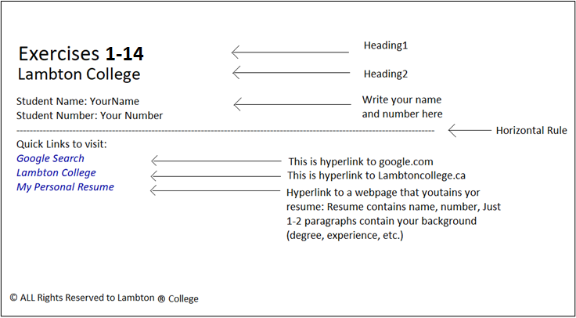

**Notes:**

* The webpage items illustrations are shown next to arrows pointing to each element
* The “***My personal Resume***” item is a link to jump to a webpage that contains your resume. The resume webpage must contain your *first name, last name, student number*, any personal and education/work information
* Your resume webpage name must be your *FirstName_lastname.html*
* The exercise webpage name will be *FirstName_Exe1.html*
* Submit your resume and the exercise webpages into Moodle by the due date and time